How to Write a Scientific Lab Report
For High Schoolers

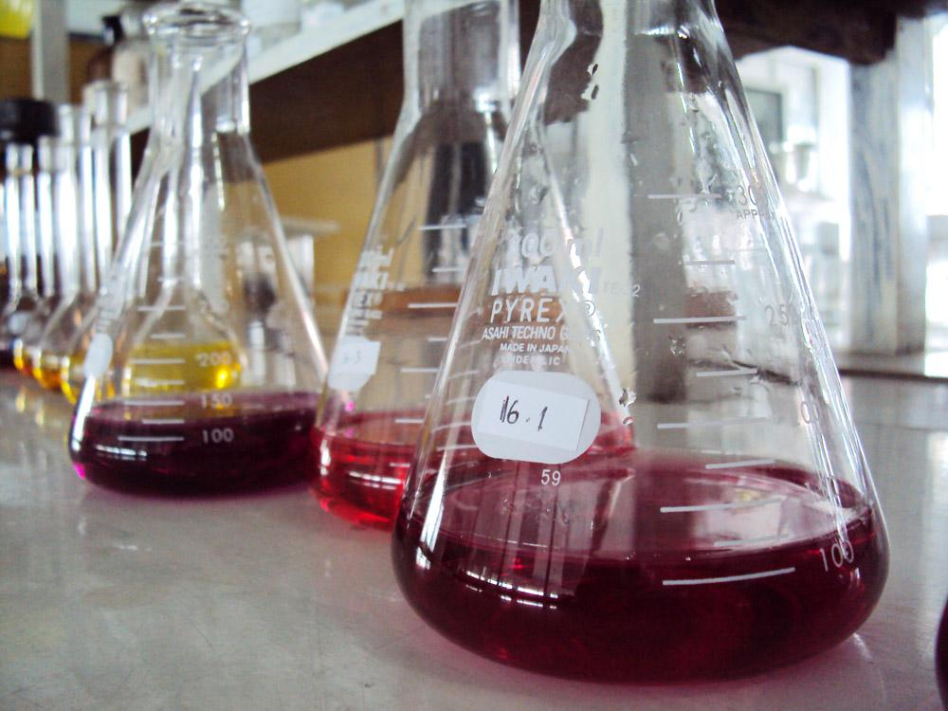
Writing a scientific lab report is a skill that seems daunting to many students. Thankfully, there is a basic formula that you can follow.

The following pages will provide you with the basic layout, format and content required to write a high school lab report.

The title of the report is usually 10 words or less and explains the purpose of the experiment.

There are conflicting ideas regarding the use of first-person voice in a scientific lab report. Many scientists believe that using first-person is inappropriate when writing a scientific report, but this is not a universal rule and students often have much difficulty with this process. An example is as follows: Instead of writing “Then I covered the cup with a paper towel”, you would write “The cup was covered with a paper towel.”

I would suggest avoiding first-person in the following circumstances:

1. Your instructor or teacher specifically forbids it.

2. You have a good bit of experience writing lab reports and are familiar with the individual sections required.

For most students, getting the formatting and sections correct is more important than worrying about using first-person.

For each of the following sections, a description of the section is provided, then an example.

Title of Lab

Student Name

Date

Abstract

An abstract is a brief summary of your entire report. A reader should be able to fully understand what you did, how you did it, what the results were, and the conclusions you made from simply reading this abstract.

The abstract is only 2 or 3 small paragraphs, so this means you will write a sentence or two from each section. This section is usually typed in single-space, while the rest of the document is double-spaced.

EXAMPLE:

ABSTRACT
Decomposition is an essential ecological process. In order to observe this process in a controlled, indoor setting, two decomposition chambers, called biobottles, were created. These biobottles were constructed from two-liter soda bottles into which organic matter was inserted. Throughout a period of approximately two months, temperature, pH, and mass of the biobottles was measured at least once per week.

It was hypothesized that the addition of ethanol would halt the process of decomposition. After adding 20 mL of 70% ethanol every two weeks, the mass and temperature of the control and experimental bottles remained relatively constant, while the pH of the experimental biobottle decreased significantly. Upon termination of the experiment, it was concluded that the similarity of the two biobottles was due to the evaporation of the ethanol, which resulted in a minimal effect upon the decomposition rate in the experimental bottle. In addition, if a larger amount of ethanol was added, a more significant decrease in the decomposition rate may have been observed.
Introduction

An introduction explains the purpose of your experiment and includes background information about your lab. This section should also include one sentence that states your hypothesis. Essentially, you explain that based on all this background information, you then made the hypothesis that…fill in the blank.

EXAMPLE:

INTRODUCTION

Decomposition of organic material is a vital ecological process. In the absence of this natural process, the supply of nutrients in the soil would be quickly depleted. Life on earth is possible because essential nutrients are continuously renewed in the soil through the decomposition of decaying plant matter.
Soil is an incredibly complex and dynamic substance, comprised of both living and nonliving matter. Decomposition is accomplished solely by microorganisms that inhabit this dynamic soil environment. “In one tablespoon of soil, you’re going to find somewhere between a billion and 2 billion organisms, and approximately 15,000 species” (Atkin 2001).

Biobottles serve as models that can be employed to analyze the dynamic process of decomposition. During the course of one week, general data was obtained from the two biobottles that were constructed by our lab group. This data was analyzed using scientific methodology, and an original experiment was designed. The purpose of this experiment was to analyze one dependent and one independent factor in the decomposition process. Our lab group analyzed the effects of 70% alcohol on the rate of decomposition. It was expected that the addition of alcohol to the experimental biobottle would kill the microorganisms present, thus slowing the overall rate of decomposition in that bottle.
Materials and Methods

This section explains the materials used and the procedures that were completed in order to finish the experiment.

The materials section can be written as a list or included the procedure.

The procedure should be written with enough detail that any reader could repeat the experiment exactly as you did it. This is, in fact, the exact purpose of writing the lab report. Scientists should always be prepared to have others read and repeat their work. This allows results to be verified through repetition or disproved, if different results were found.

Diagrams, photographs, and pictures can be included in this section, if necessary.

EXAMPLE:

MATERIALS AND METHODS

The lab group constructed the two biobottles (Figure 4) using three 2-liter bottles each. The bottoms were cut off two of the bottles, and grass was placed in one of the bottles. Then one cut end was placed inside of the other cut end, and the two bottles were melted together in three places. The holes that were created by melting the two bottles together were then covered with screened nylon to keep in insects. The chamber that resulted was called the “decomposition chamber.” These two bottles that were in one piece were placed in another 2-liter plastic bottle that had been cut in half. This third bottle would serve as a place to collect drain water.
The group placed 40 mL of water into each of the decomposition chambers. This was enough for the grass (which weighed about 100 grams per decomposition chamber) to become saturated with water. The water would jumpstart the decomposition process.
The creation of the biobottles was now complete. From here, the group measured the weight of each of the bottles, followed by the temperature at the center of the grass, the pH of the water that had drained into the third bottle, observed the odor, and took notes on other observations. Group members would repeat this process many times across the next 1.5 months.
One week later, one biobottle would be left alone for the control. The other biobottle received the alcohol once every two weeks. Each time that alcohol was added to the biobottle, the other biobottle received the same amount of water.
Results

This section provides all the raw data that you collected from your experiment. Traditionally, a scientific experiment will collect quantitative data (in the form of numbers), however qualitative data can also be included here, if necessary.

This section provides information only. Diagrams, tables, photographs and other data can be included here, or you can list a parenthetical notation that directs the reader to these items in another page of the report, if they take up too much room here.

Do not interpret the data and results in this section. Save your conclusions and analysis of the information for the following section.

EXAMPLE:

RESULTS
The pH of the two biobottles was tested with a pH probe at least once a week. The pH of biobottle 2, the control, remained relatively stable during the entire experimentation period (Figure 1). Both biobottles initially were found to have a pH near 9 and the control biobottle consistently gave pH results near this level (Table 1). A pH of 9 is considered to be basic on the pH scale. The experimental bottle, however, had varied pH results. It began with a pH similar to the control bottle, but after the first addition of ethanol, the pH dropped significantly to 7.8. After three days, the pH returned to near 9 until the last three measurements. During this time period, the pH dropped to less than 5.
The mass of the biobottles was also measured during each data collection time, which was at least once a week. Both biobottles began with a weight of approximately 246 grams, and remained near this point for most of the experimentation period (Table 2). For the last two measurements, the mass dropped to less than 200 grams for both biobottles. Overall, both biobottles tended to follow the same trend in weight change during the experimentation period, although the control biobottle was consistently slightly higher in mass than the experimental bottle (Figure 2).

The last piece of data that was collected each week was the temperature of the decomposing matter in each biobottle. The temperature was measured with a temperature probe. The temperature of both biobottles initially was found to be approximately 29 degrees Celsius (Table 3). After the initial measurement, both biobottle temperatures decreased slightly over the experimental time period (Figure 3).
Discussion

This section is where you discuss the conclusions that you were able to draw from the data in the results section. You should also discuss whether your hypothesis was correct or incorrect. If it was incorrect, you should provide reasons why that might be. These reasons might include experimental error, contamination of specimens, or maybe you just learned new information about your topic that wasn’t expected or previously known.

So take a look at your tables, graphs, photographs, and diagrams from the results section and try to determine a trend from this information. After reading this section, other scientists should understand how this information changes what we know about this topic or if it verifies information previously known.

EXAMPLE:

DISCUSSION
After the first application of alcohol to Biobottle 1, initial observations recorded that a multitude of macroorganisms had retreated to the boundary of the bottle where they died. No live organisms or movement in the system was recorded. Comparatively, Biobottle 2, the system treated with water, displayed a plethora of live organisms, including mites, molds, and tiny flies, actively interacting with their environment. In addition, the odor of the “live” bottle gave evidence that living microorganisms were viable and involved in the decomposition process. From these observations, the expected results seemed to be occurring.
Yet, upon quantitative analysis, the data did not demonstrate those conclusions. In fact, the opposite seemed to be occurring with further applications. Ultimately, the mass of the Biobottle treated with alcohol was lower than the Biobottle given water treatment. Evaporation rates, however, differ between water and alcohol. Observations recorded water drainage even though no drainage was recorded from the alcohol treated bottle. Alcohol at 70% freely evaporates in the laboratory and diffuses out through the ventilation holes to establish equilibrium with the surrounding environment. Water will not as freely evaporate under laboratory conditions nor exit the bottle system through the air holes because of the moisture content already present in the room’s air. These considerations could have altered the recorded weight of Biobottle 2 with up to a 20-gram increase (20 mL of water, D = 1g/mL).

Several factors complicated the actual conclusions that could have been drawn from the data collected. Improvements to the experimental design addressing these factors may still reveal

Figures

This is where your graphs, charts, tables, and photographs will be included. Each should be appropriately labeled with a number so that you can reference them in the results or discussion sections. No figures should be included that are not somehow referenced in other sections.

All graphs and tables should be labeled with units and descriptions. Graphs also require a title. If you want, you can include a caption under the figure with a description of what it is showing.

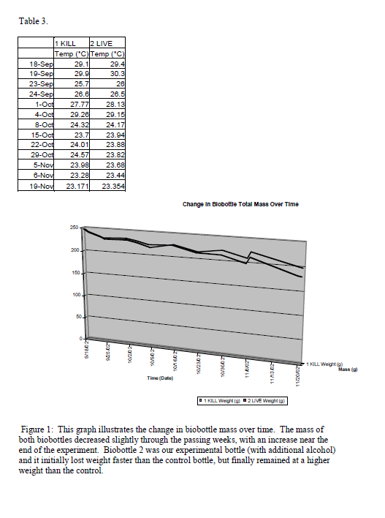EXAMPLE:
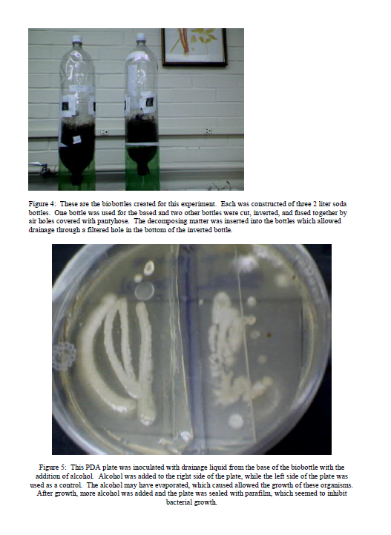
Literature Cited/Bibliography

This is where you cite the sources used for background information in the introduction. If you cited a source directly, a parenthetical notation should be included within the writing. If you simply used the sources as a reference, you can skip the parenthetical notation, but list the source here.

The format you use can be MLA or APA, unless your instructor gives you specific instructions.

EXAMPLE:

LITERATURE CITED

Atkin, R. 2001. He has a down-to-earth recipe for gardening success. Christian Science

Monitor. 93: 14-17.

The following pages include 2 types of rubrics I’ve used to grade lab reports. They can be edited and adjusted as needed.
Lab Report Grading Rubric

Title Page _______ out of 3 points

Introduction
Problem _______ out of 2 points

Hypothesis _______ out of 2 points

Research _______ out of 5 points

Materials & Methods _______ out of 10 points

Results _______ out of 10 points

Discussion
Hypothesis
correct? _______ out of 2 points

Application _______ out of 2 points

Figures _______ out of 10 points

Literature Cited _______ out of 10 points

BONUS:
Student did not use first person (I or you). +2

Self | Peer | Teacher |  | Points
 |  |  | Appearance/Organization  - Lab Report is typed  - Lab report uses headings and subheadings to visually organize material  - cover page includes name, teachers name, date, title | 5
 |  |  | Abstract (Written last)  - The whole paper has been condensed into miniature form.  - There are approximately 5-10 sentences.  - There is no new information, no supporting material, & limited details. | 10
 |  |  | Introduction  - The primary topic/goal of the study is explained in clear, concise terms.  - 4 or more reputable background sources were used & cited correctly.  - Material is translated into student's own words.  - Background information is pertinent to topic & improves reader understanding of the investigation & report. | 20
 |  |  | Materials & Methods  - Complete & detailed list of materials in 2 vertical columns.  - Methods are listed in clear steps that are easy to follow & reproducible by another person. | 10
 |  |  | Observation Sheet  - Observations are clear, accurate, and dated.  - Observation sheet is referenced in report. | 10
 |  |  | Results  (Answer the question "What did I find out?")  - Organized and clear representation of data using tables & graphs with correct titles.  - Correct units are used when necessary.  - Explain your actual findings. Link your writing to graphs & tables as you present your results.  (Save broad generalizations & conclusions for later) | 20
 |  |  | Discussion  - Describes what was learned from the experiment.  - Explains sources of error.  - Discusses variables and trends/patterns found in results.  - Predictions are made or an explanation of further studies are addressed.  - Explanation of how information applies to the real world. | 20
 |  |  | Spelling/Grammar/Punctuation  - There are 1 or fewer errors in punctuation & grammar in the report. | 5
 |  |  | Literature Cited  - All references are listed in APA format & cited correctly.  - Each source was cited in report. | 10
Total= 110 points

